SEC Form 3
FORM 3 | UNITED STATES SECURITIES AND EXCHANGE COMMISSION  Washington, D.C. 20549  INITIAL STATEMENT OF BENEFICIAL OWNERSHIP OF SECURITIES  Filed pursuant to Section 16(a) of the Securities Exchange Act of 1934  or Section 30(h) of the Investment Company Act of 1940
  OMB APPROVAL
  OMB Number: | 3235-0104
  Estimated average burden
  hours per response: | 0.5
1. Name and Address of Reporting Person*  (Street) | 2. Date of Event Requiring Statement (Month/Day/Year)  09/15/2026 | 3. Issuer Name and Ticker or Trading Symbol  Fluence Energy, Inc. [ FLNC ]  Foreign Trading Symbol
  Coughlin Stephen
  (Last) | (First) | (Middle)
  C/O FLUENCE ENERGY, INC.
  2107 WILSON BOULEVARD, SUITE 900
  ARLINGTON | VA | 22201
  (City) | (State) | (Zip)
 |  | 4. Relationship of Reporting Person(s) to Issuer  (Check all applicable) | 5. If Amendment, Date of Original Filed (Month/Day/Year)
   | Director |  | 10% Owner
   | Officer (give title below) |  | Other (specify below)
6. Individual or Joint/Group Filing (Check Applicable Line)
Form filed by One Reporting Person
Form filed by More than One Reporting Person

Table I - Non-Derivative Securities Beneficially Owned
1. Title of Security (Instr. 4) | 2. Amount of Securities Beneficially Owned (Instr. 4) | 3. Ownership Form: Direct (D) or Indirect (I) (Instr. 5) | 4. Nature of Indirect Beneficial Ownership (Instr. 5)
Table II - Derivative Securities Beneficially Owned
(e.g., puts, calls, warrants, options, convertible securities)
1. Title of Derivative Security (Instr. 4) | 2. Date Exercisable and Expiration Date (Month/Day/Year) |  | 3. Title and Amount of Securities Underlying Derivative Security (Instr. 4) |  | 4. Conversion or Exercise Price of Derivative Security | 5. Ownership Form: Direct (D) or Indirect (I) (Instr. 5) | 6. Nature of Indirect Beneficial Ownership (Instr. 5)
1. Title of Derivative Security (Instr. 4) | Date Exercisable | Expiration Date | Title | Amount or Number of Shares | 4. Conversion or Exercise Price of Derivative Security | 5. Ownership Form: Direct (D) or Indirect (I) (Instr. 5) | 6. Nature of Indirect Beneficial Ownership (Instr. 5)
Explanation of Responses:
Remarks:
Exhibit 24 - Power of Attorney
No securities are beneficially owned.
 | /s/ Leah Patterson as Attorney-in-Fact for Stephen Coughlin | 09/21/2026
 | ** Signature of Reporting Person | Date
Reminder: Report on a separate line for each class of securities beneficially owned directly or indirectly.
* If the form is filed by more than one reporting person, see Instruction 5 (b)(v).
** Intentional misstatements or omissions of facts constitute Federal Criminal Violations See 18 U.S.C. 1001 and 15 U.S.C. 78ff(a).
Note: File three copies of this Form, one of which must be manually signed. If space is insufficient, see Instruction 6 for procedure.
Persons who respond to the collection of information contained in this form are not required to respond unless the form displays a currently valid OMB Number.
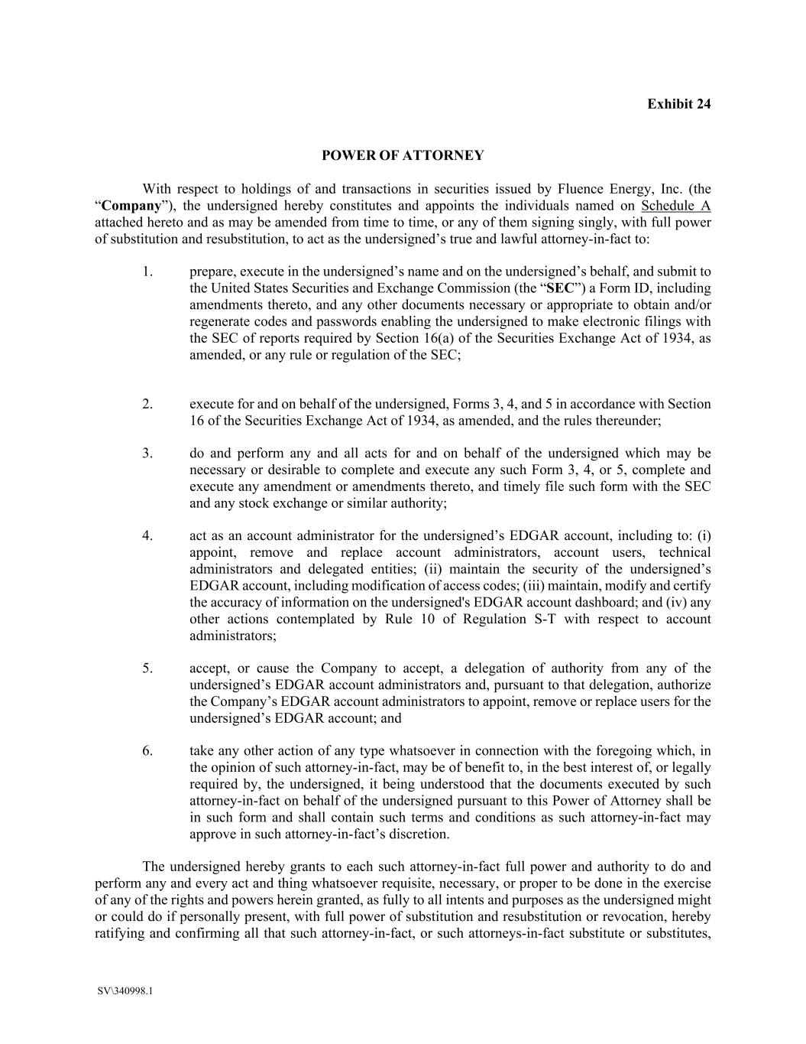
Exhibit 24 SV\340998.1 POWER OF ATTORNEY With respect to holdings of and transactions in securities issued by Fluence Energy, Inc. (the “Company”), the undersigned hereby constitutes and appoints the individuals named on Schedule A attached hereto and as may be amended from time to time, or any of them signing singly, with full power of substitution and resubstitution, to act as the undersigned’s true and lawful attorney-in-fact to: 1. prepare, execute in the undersigned’s name and on the undersigned’s behalf, and submit to the United States Securities and Exchange Commission (the “SEC”) a Form ID, including amendments thereto, and any other documents necessary or appropriate to obtain and/or regenerate codes and passwords enabling the undersigned to make electronic filings with the SEC of reports required by Section 16(a) of the Securities Exchange Act of 1934, as amended, or any rule or regulation of the SEC; 2. execute for and on behalf of the undersigned, Forms 3, 4, and 5 in accordance with Section 16 of the Securities Exchange Act of 1934, as amended, and the rules thereunder; 3. do and perform any and all acts for and on behalf of the undersigned which may be necessary or desirable to complete and execute any such Form 3, 4, or 5, complete and execute any amendment or amendments thereto, and timely file such form with the SEC and any stock exchange or similar authority; 4. act as an account administrator for the undersigned’s EDGAR account, including to: (i) appoint, remove and replace account administrators, account users, technical administrators and delegated entities; (ii) maintain the security of the undersigned’s EDGAR account, including modification of access codes; (iii) maintain, modify and certify the accuracy of information on the undersigned's EDGAR account dashboard; and (iv) any other actions contemplated by Rule 10 of Regulation S-T with respect to account administrators; 5. accept, or cause the Company to accept, a delegation of authority from any of the undersigned’s EDGAR account administrators and, pursuant to that delegation, authorize the Company’s EDGAR account administrators to appoint, remove or replace users for the undersigned’s EDGAR account; and 6. take any other action of any type whatsoever in connection with the foregoing which, in the opinion of such attorney-in-fact, may be of benefit to, in the best interest of, or legally required by, the undersigned, it being understood that the documents executed by such attorney-in-fact on behalf of the undersigned pursuant to this Power of Attorney shall be in such form and shall contain such terms and conditions as such attorney-in-fact may approve in such attorney-in-fact’s discretion. The undersigned hereby grants to each such attorney-in-fact full power and authority to do and perform any and every act and thing whatsoever requisite, necessary, or proper to be done in the exercise of any of the rights and powers herein granted, as fully to all intents and purposes as the undersigned might or could do if personally present, with full power of substitution and resubstitution or revocation, hereby ratifying and confirming all that such attorney-in-fact, or such attorneys-in-fact substitute or substitutes,

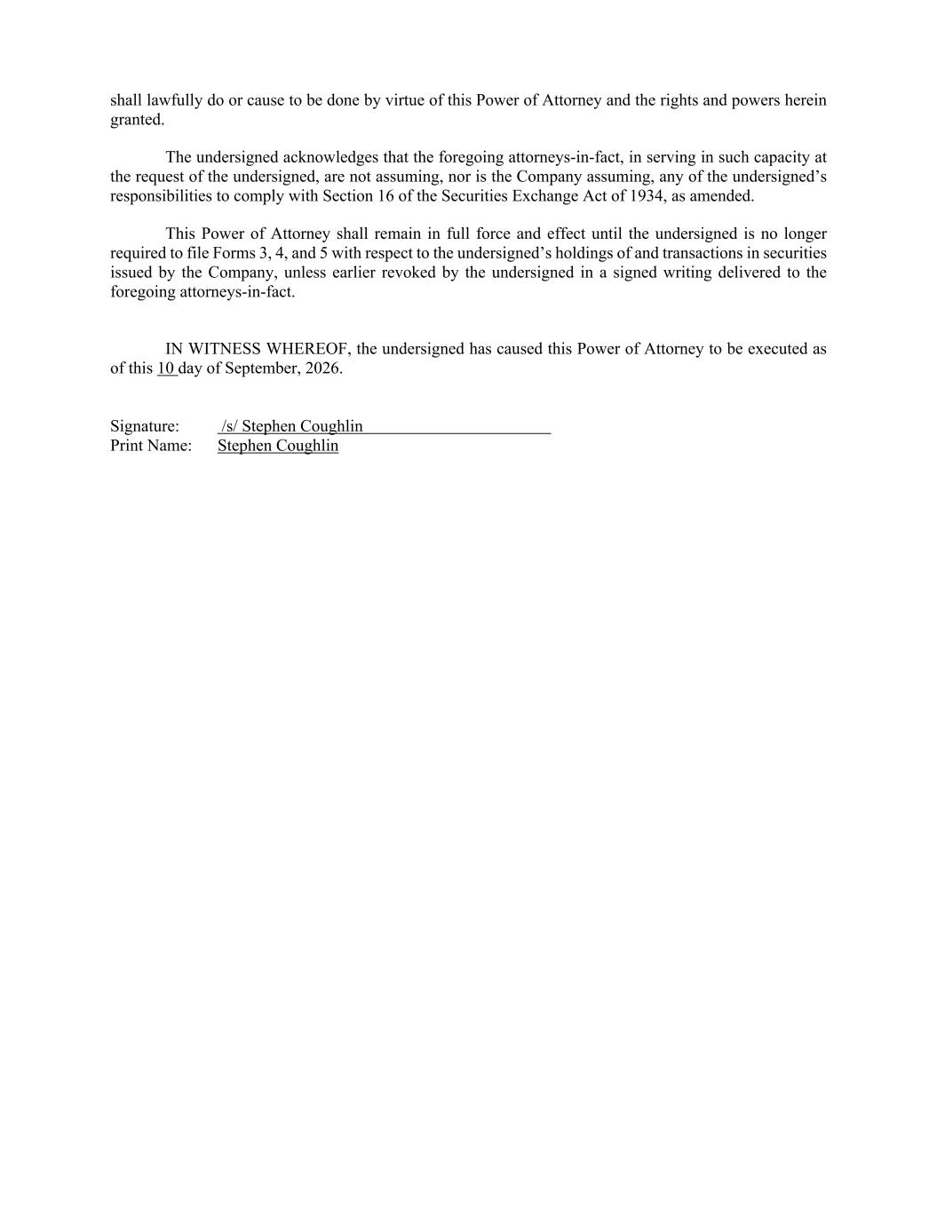
shall lawfully do or cause to be done by virtue of this Power of Attorney and the rights and powers herein granted. The undersigned acknowledges that the foregoing attorneys-in-fact, in serving in such capacity at the request of the undersigned, are not assuming, nor is the Company assuming, any of the undersigned’s responsibilities to comply with Section 16 of the Securities Exchange Act of 1934, as amended. This Power of Attorney shall remain in full force and effect until the undersigned is no longer required to file Forms 3, 4, and 5 with respect to the undersigned’s holdings of and transactions in securities issued by the Company, unless earlier revoked by the undersigned in a signed writing delivered to the foregoing attorneys-in-fact. IN WITNESS WHEREOF, the undersigned has caused this Power of Attorney to be executed as of this 10 day of September, 2026. Signature: /s/ Stephen Coughlin Print Name: Stephen Coughlin

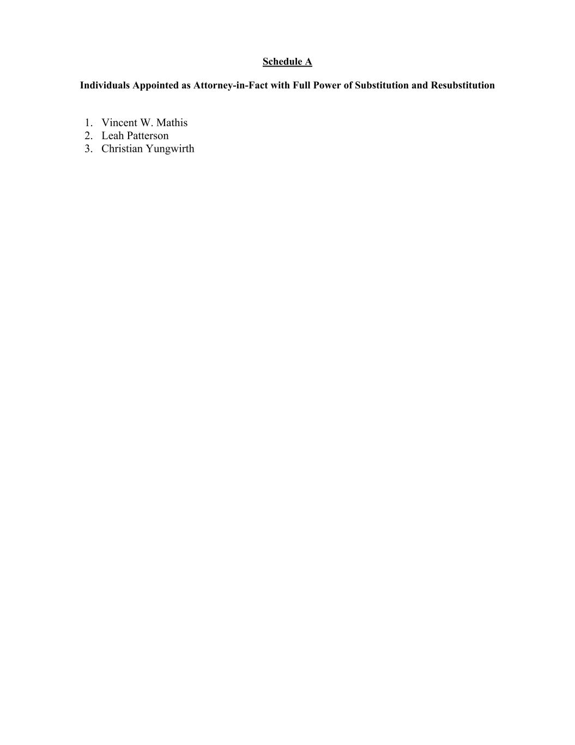
Schedule A Individuals Appointed as Attorney-in-Fact with Full Power of Substitution and Resubstitution 1. Vincent W. Mathis 2. Leah Patterson 3. Christian Yungwirth

